PRESIDENT OFFICE
REGIONAL ADMINISTRATION AND LOCAL GOVERNMENT
FORM FOUR NWZ MOCK EXAMINATIONS- 2025
BIOLOGY 2A MARKING SCHEME
- a) The food report of food sample solution N
FOOD TESTED | PROCEDURES | OBSERVATION | INFERENCE
Starch | To 2cm3 of solution R1 in a test tube, two drops of iodine solution were added then shaken | The mixture retained the colour of iodine solution | Starch was absent
Reducing sugar | To 2cm3 of solution R1 in a test tube, 2cm3 of Benedict’s solution was added then boiled | The series of colour changed from blue, green, yellow, orange finally to brick red observed | Reducing sugar was present
Non reducing sugar | To 2cm3 of solution R1 in a test tube, 1cm3 of diluted Hydrochloric acid was added then shaken and boiled for two minutes then cooled, followed by addition of 2cm3 of Sodium hydroxide and 2cm3 (equal amount) of Benedict’s solution then boiled | The series of colour change observed from blue, green, yellow, orange finally to brick red | Non reducing sugar was present
Protein | To 2cm3 of solution R1 in a test tube, 2cm3 of sodium hydroxide solution was added, followed by two drops of 1% copper II sulphate solution, then shaken | The colour of the mixture was changed to purple | Protein was present
Lipids | To 2cm3 of solution R1 in a test tube, 3 drops of Sudan III solution were added then shaken vigorously and left to settle for five minutes | The red ring was formed on the top of the mixture | Lipid was present

- i) Protein
ii) Organ S is Liver
Organ T is Kidney
Substance P is Urea
Liquid Q is Urine
- Excess amino acids was converted to ammonia which is poisonous, if it is allowed to accumulate in the body it will interfere the metabolic activities and may cause death of an organism.
- i) The malnutrition disorder is Kwashiorkor
- ii) Symptoms of the disorder
- Retarded growth
- Dry skin that crack easily
- Swelling feet ( Oedema)
- Protruding abdomen
- Soft and brownish hair.

02. a)( i) The common names of the specimens.
Specimen | Common name
O | Hibiscus flower
P | Bean seed
Q | Maize grain
R | Scapula bone
(ii) Classification of the specimens to class level
Specimen | Kingdom | Division | Class
O | Plantae | Angiospermophyta | Dicotyledoneae
P | Plantae | Angiospermophyta | Dicotyledoneae
Q | Plantae | Angiospermophyta | Dicotyledoneae
R | Plantae | Angiospermophyta | Monocotyledoneae

b) (i) The agent of pollination is Insects
(ii) The adaptations of specimen O to be pollinated by insects are
- Have bright coloured petals to attract insects.
- Have nectar to attract insects to enter inside the flower.
- Have scent (good smell) to attract insects.
- Have sticky pollen grain which enables it to stick to the body of an insect.

b) (iii) The diagram of specimen O (Hibiscus flower) showing female parts.
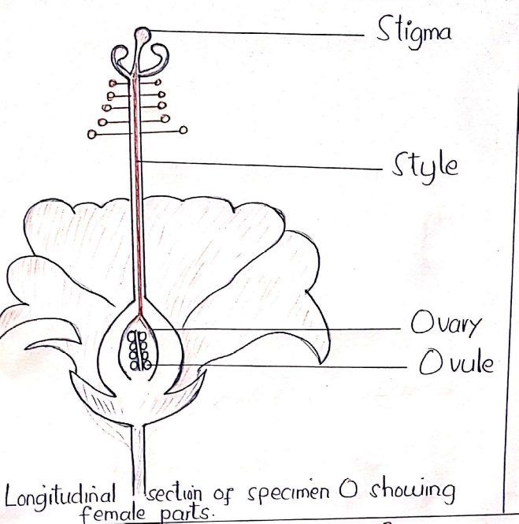
c) (i) Specimen R was obtained at the shoulder.
(ii) The type of joint is ball and socket joint.
Reason; Specimen has glenoid cavity at the top into which a round head of another bone fit to allow movement in all direction.

d) (i) Difference between specimen P (bean seed) and Q (maize grain)
Specimen P (bean seed) | Specimen Q ( maize grain)
- The seed leaves has two cotyledon | The seed leaves has one cotyledon
- The leaves have network venation | The leaves have parallel venation
- They have tap root system | They have fibrous root system
- They have short and broad leaves | They have long and narrow leaves
(ii) - The type of germination in specimen P is Epigeal germination
- The type of germination in specimen Q is hypogeal germination.
(iii) Economic importance of kingdom to which specimen P and Q are belongs;
ADVANTAGES.
- They are source of food to human being and other animals
- They are source of timber used in construction.
- They are habitat for wild animals.
- They are source of medicine
DISADVANTAGES
- Some members produce toxic substance that can harm or kill human being and other animals
- Pollen from many members causes allergies to human being
- Some plants act as hosts for pests and pathogens which causes diseases.
- Some members are weed to the expected crops.
- Some members produces flammable oil that increases the risk of wildfire

